Steps To Install Allure In Jenkins

1. Create a new Project using Maven project plugin.

* *Give the Name of the project.*
* *Click on the Maven project.*
* *Click on the OK button.*

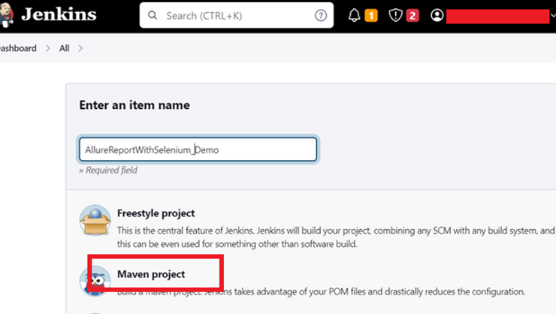

2. In the General section, enter the project *description* in the Description box and Select *Source Code Management as None* if the project is locally present on the machine.

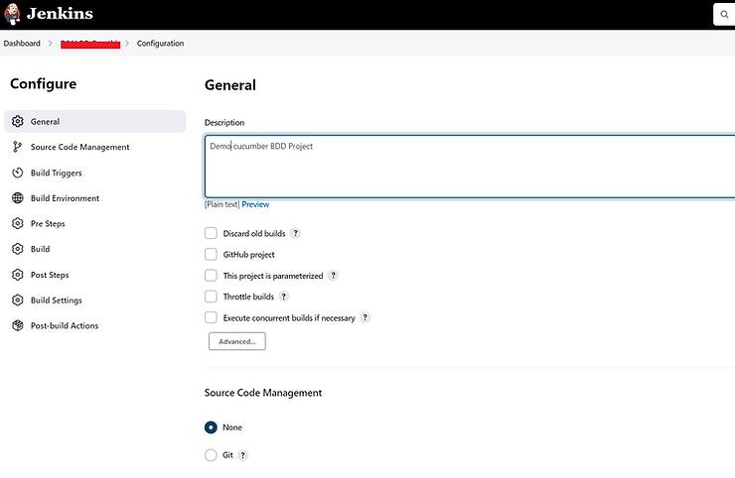

3. In Build Management section

* In the Root POM textbox, enter *pom.xml.*
* In the Goals and options section, enter “*clean test*” .

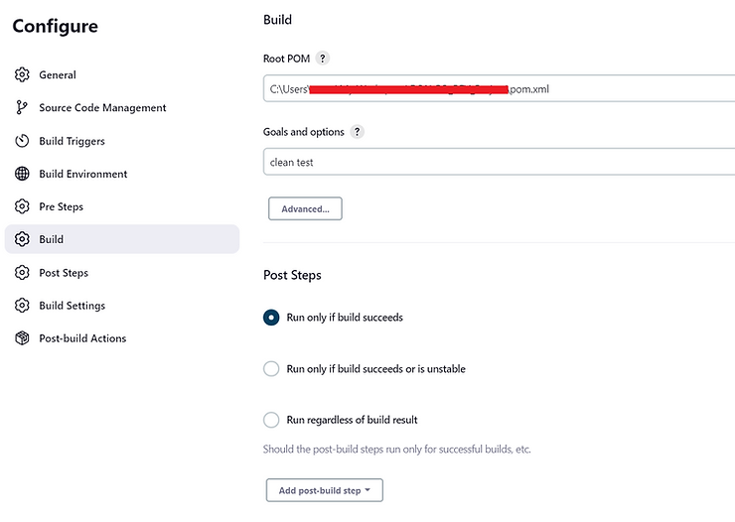

4. Then we will add Allure Plugins. For that click Manage Jenkins.

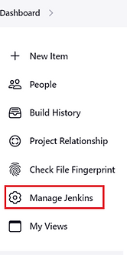

5. In system configuration click Manage plugins .

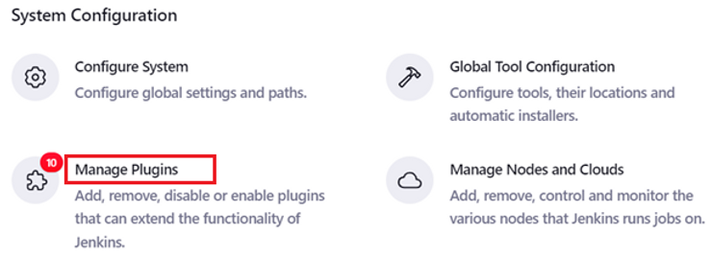

6. click Available Plugins.

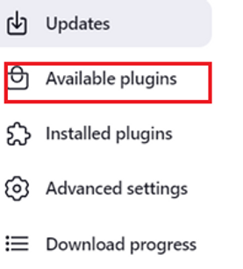

7. Search Allure Jenkins Plugin and select Install without restart.



8. In Manage Jenkins click Global Tool Cofiguration.



9. In Allure commandline name box we have to give allure serve and maven version also we have to give then select install automatiaclly check box. And click save button.

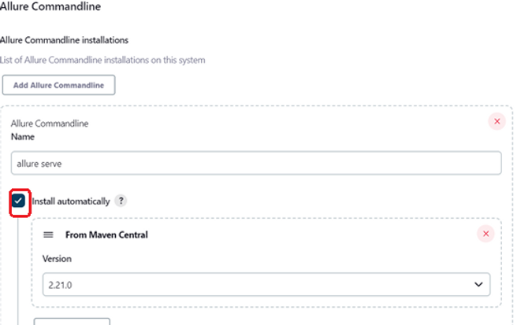

10. In configure Post-build Actions add the path of the allure results and click save button.

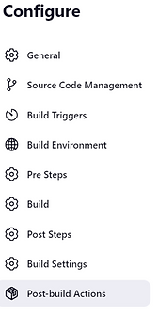

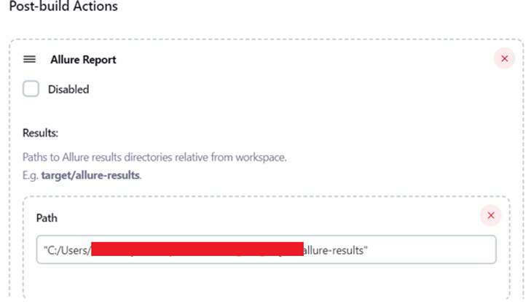

11. It will generate allure -results for each build through Jenkins.

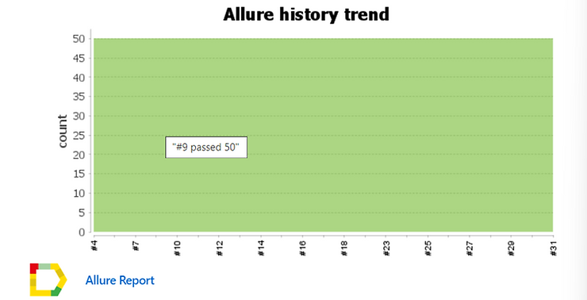



12. we will get the same allure reports as we shown before in eclipse Place.

Conclusion:

Allure Report and Jenkins contribution may save your time because Allure Report plugin works very well in Jenkins and serves an amazing dashboard for the report in short period of time.

I believe that you have learnt about How to generate Allure reports through this blog. Thank You For reading my blog.